Data collection from Kaggle repository and Uploaded:

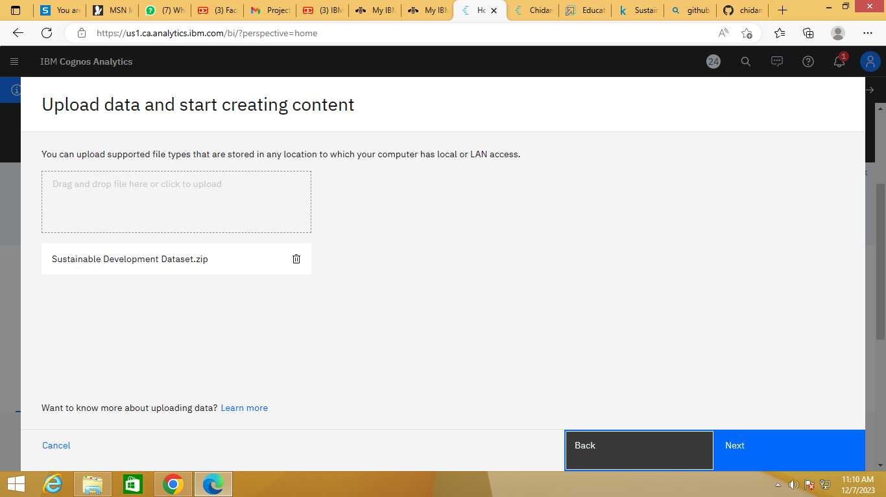

Connect with IBM Cognos:

